EV Market Segmentation Analysis Report

Author: Tushar Pawar
Github Link: https://github.com/tanuj-cmd-15/EV-Market-Segmentation

1) Introduction:
The Indian automotive market has historically been dominated by non-electric vehicles (NEVs). The popularity of NEVs stems from their affordability, low maintenance costs, and readily available fuel infrastructure. However, the Electric Vehicle (EV) market in India is experiencing a rapid surge in popularity, attracting major automotive brands such as TATA, Mahindra, and international companies.
This report analyzes the Indian EV market to identify potential opportunities for a new EV startup. The goal is to develop a unique EV product that can compete with established brands while appealing to price-conscious Indian consumers.
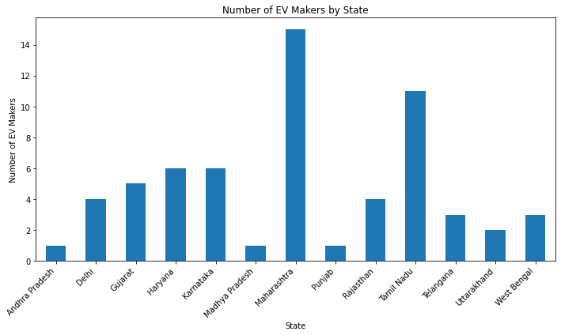
2) Market Information:
a) General Usage Info:
- EVs currently represent less than 1% of total vehicle sales in India.
- The EV market is projected to reach INR 475 billion by 2025.
- Two-wheelers dominate the market (62%), followed by three-wheelers (37%).
- The four-wheeler segment has the lowest EV penetration (0.12%), but is expected to grow to 5% by 2025.
- Market penetration varies significantly by state, influenced by factors such as demographics, income levels, regulations, and urbanization.

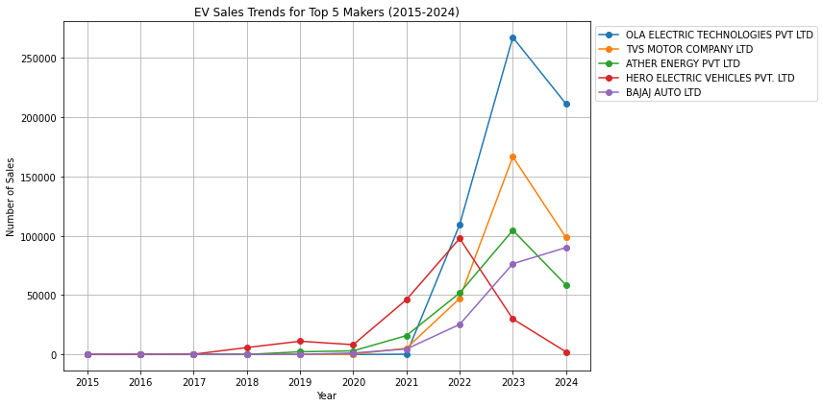
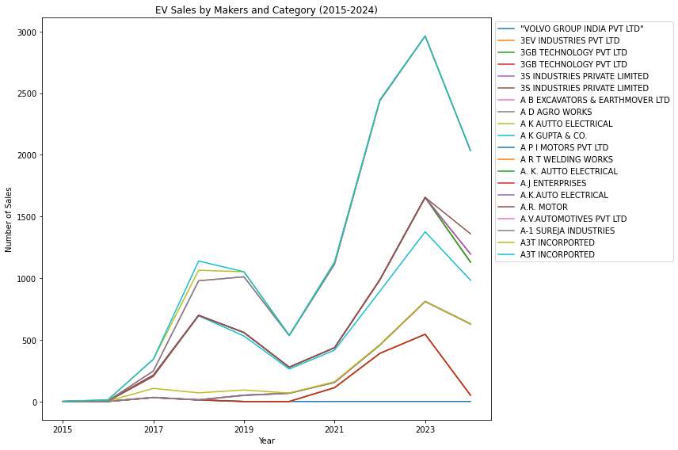
b) Battery Info:
- Lead-acid batteries currently dominate the market, but lithium-ion batteries are gaining traction due to government incentives and demand from two-wheelers.
- The government has set target driving ranges for different EV categories, which influences battery capacity and energy consumption.
- EV battery lifespans are influenced by factors such as charging cycles, speed, and temperature.
- Retired EV batteries can be repurposed for second-life applications like grid-scale energy storage, maximizing their economic value.
- Second-life applications align with India's renewable energy goals and can extend battery life by another 10 years.
3) Market Segmentation Analysis:
This analysis utilizes data from various sources, including government websites, car research platforms, and market research.
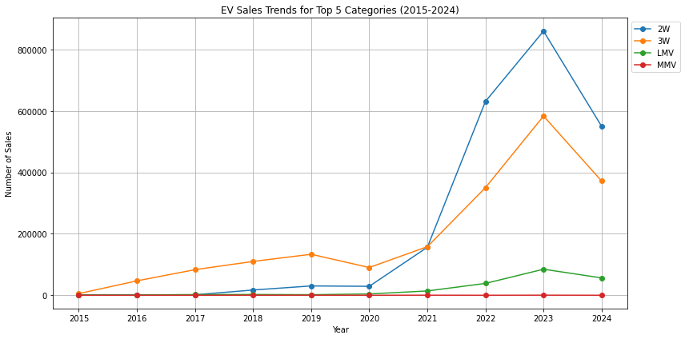
a) Visualization Analysis:
(a) Geographic and Demographic Research:
- South India:
  - Tech hub with strong EV demand.
  - Significant charging infrastructure.
  - Major manufacturing plants of popular EV brands.
- Delhi:
  - Highest number of charging stations.
  - Relatively low EV popularity.
- North-East India:
  - Growing EV popularity.
- Other States/Regions:
  - Balanced numbers and competitive demand.
- Daman and Diu and Lakshadweep:
  - Insufficient data for analysis.
- Charging Station Availability:
  - Maharashtra has the highest number of EV makers with 15.
  - The states of Tamil Nadu, Haryana, and Karnataka have a significant number of EV makers, with over 6.
  - Delhi, Gujarat, and Telangana have a moderate number of EV makers.
  - The states of Andhra Pradesh, Madhya Pradesh, Punjab, Rajasthan, Uttarakhand, and West Bengal have a lower number of EV makers.
  - The data suggests that Maharashtra is a leading state in India for EV manufacturing.
  - The states with a higher number of EV makers are likely to have a more developed EV ecosystem.
  - The presence of EV makers in a state indicates the availability of resources, infrastructure, and skilled labor.
  - The state governments may be playing a role in encouraging EV manufacturing by providing incentives or subsidies.
  - The growth of the EV industry in India is evident from the increasing number of EV makers in different states.
  - The data can be useful for policymakers and investors who are looking to invest in the EV industry in India.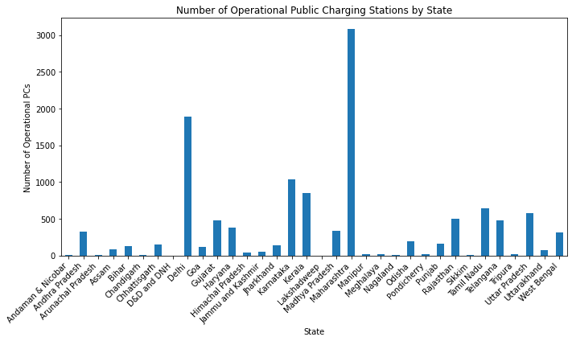

(b) Psychographic and Behavioral Research:
- Petrol Cars:
  - Most popular (79% market share).
  - Cheaper than diesel and CNG cars.
- Diesel Cars:
  - 20% market share.
  - More expensive, but offer high performance and durability.
- CNG Cars:
  - Lowest popularity.
  - Limited performance and durability, but offer fuel economy.
- EV Price:
  - A major concern for most consumers.
  - Consumers prioritize low-priced and low-maintenance vehicles.
b) Segmentation Analysis:
- Principal Component Analysis:
  - Identifies key variables contributing to consumer preferences for EVs.
  - Value for money, performance, and fuel economy are key features influencing EV purchase decisions.
- Segment Extraction:
  - Four distinct segments were identified based on consumer responses to EVs.
  - Segments 1 and 4 exhibit strong positive sentiments towards EVs, making them attractive target markets.
  - Segment 3 displays balanced sentiments, suggesting potential with targeted marketing.
  - Segment 2 holds negative sentiments toward EVs, rendering them unattractive for EV targeting.
(c) Economical Research:
- Analyzes technical specifications and ideal price points for EVs.
- Recommends a price range of INR 9.46 Lakhs to INR 39.5 Lakhs.
- Identifies a battery capacity range of 26.0 kWh to 107.8 kWh.
- Sets driving range targets between 315 km and 857 km.
- Defines a power range of 73.75 BHP to 516.29 BHP.
- Recommends charging times between 1.5 hours and 9.0 hours.
4) Conclusion:
a) Geographic and Demographic Analysis:
- South India: Competitive market with established brands, presenting challenges for a new EV startup.
- North-East India: Growing popularity of EVs, offering a promising entry point for a new brand.
- East India and Central India: Potential target markets after establishing a presence in North-East India.
b) Psychographic and Behavioral Analysis:
- Consumers prioritize price and maintenance costs, favoring low-priced and durable EVs.
- Positive sentiments towards EVs among consumers who have tested or owned them.
- Effective marketing highlighting features and performance can attract potential customers.
c) Economical Analysis:
- The recommended price and technical specifications create a competitive advantage in the market.
- Optimization of battery capacity, power, and driving range can maximize cost-effectiveness.
- Fast charging capabilities are essential to enhance user experience and minimize charging time.
Final Thoughts on Startup Strategy:
- E-Bikes: Target East Indian states like Uttar Pradesh, Bihar, and West Bengal, as well as Central Indian states like Madhya Pradesh, due to their affordability and growing popularity of e-bikes.
- E-Cars: Focus on North-East India and Central India as initial target markets, followed by East India.
- South India: A challenging market due to strong competition from established brands; consider targeting this market after establishing a strong presence in other regions.
- North India: Not recommended as a target market due to low EV adoption despite the availability of charging infrastructure.
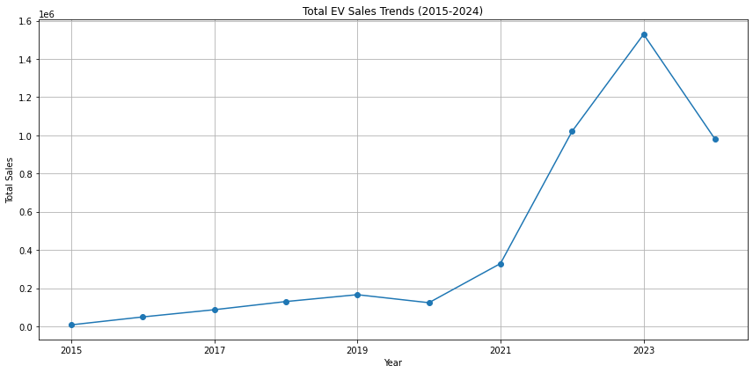
Overall, this report provides a comprehensive analysis of the Indian EV market and offers insights for developing a successful EV startup strategy. By understanding the market segments, consumer preferences, and regional differences, a new EV brand can position itself effectively and achieve sustainable growth.

